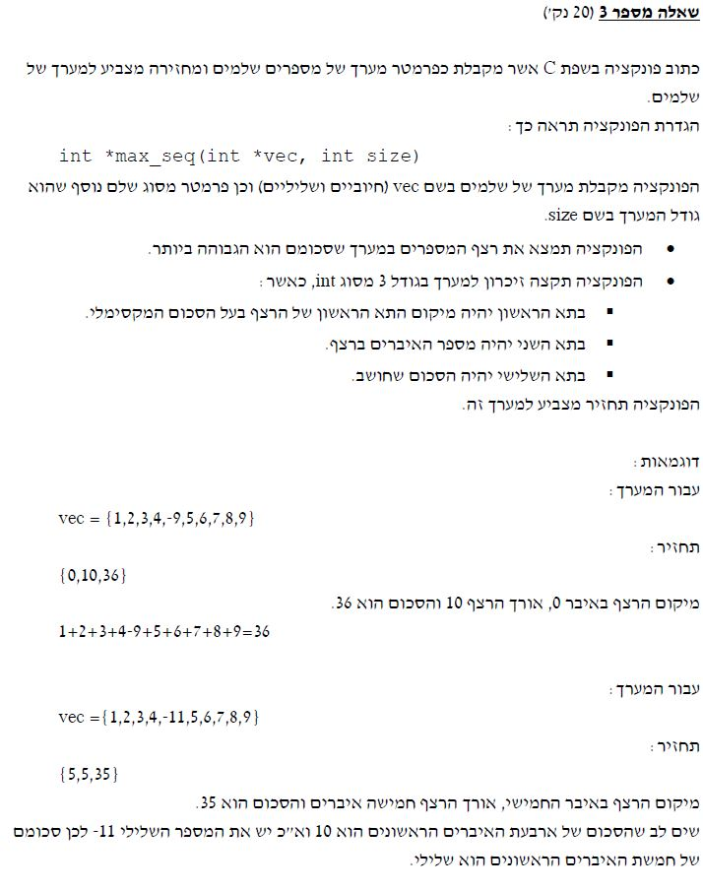

#include <stdio.h>

#include <stdlib.h>

// Answer 3: find max sequence in array:

int *max_seq(int *vec, int size)

{

int i, max_so_far = 0, max_end = 0, current_index = 0;

int *vec2 = (int *)calloc(3, sizeof(int));

//Checking the array max

for (i = 0; i < size; i++)

{

max_end = max_end + vec[i];

//Checking uf max is negative

if (max_end <= 0)

{

max_end = 0;

current_index = i + 1;

}

else

//If max is positive palcing start and end of maximum contiguous

if (max_so_far < max_end)

{

max_so_far = max_end;

vec2[0] = current_index;

vec2[1] = size - current_index;

}

}

//Placing the max in the new array

vec2[2] = max_so_far;

return vec2;

}

int main()

{

//int vec[] = { 1,2,3,4,-9,5,6,7,8,9 };

int vec[] = { 1,2,3,4,-11,5,6,7,8,9 };

int i;

int size = sizeof(vec) / sizeof(vec[0]);

int *vec2 = max_seq(vec, size);

puts("Original Array:");

for (i = 0; i < size; i++)

printf("Vec[%d]=%2d\n", i, vec[i]);

puts("\nNew max seq array:");

for (i = 0; i < 3; i++)

printf("Vec[%d]=%2d\n", i, vec2[i]);

getchar();

return 0;

}